Product Features Applications

- 2856 MHz
- Output power: 1200W(Pulse) Peak Power
- Built with GaN on SiC HEMT
- 35% Amp Efficiency
- High Reliability
- Excellent Frequency Stability
- Power & Frequency Monitoring Available
- Building Block for High-Power Systems
- Plasma Generation
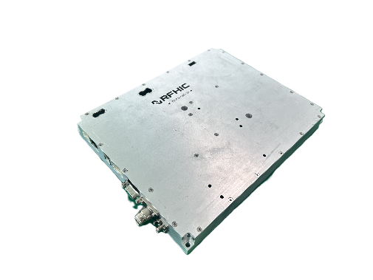
- Industrial Heating and Drying
- Microwave CVD
- Microwave Sintering
- Microwave Chemistry
- Materials Processing
- Study of Biological Phenomena
- Semiconductor Equipment

Description
The RIM281K2-20 is a 1200W, GaN solid-state power amplifier designed for high power industrial, scientific, and medical (ISM) applications. The solid-state power amplifier is operable from 2856 MHz and is built using RFHIC’s cutting edge gallium- nitride (GaN) on SiC HEMT providing excellent efficiency and breakdown voltage.
The GaN Solid state Power Amplifier (SSPA) is suitable for use in pulse applications. This high efficiency rugged device is targeted to replace industrial magnetrons and other vacuum tubes currently powering industrial heating, drying, microwave CVD and sintering.
Electrical Specifications @ VDS =50V, T=25°C, 50Ω System

PARAMETER |  | UNIT | MIN | TYP | MAX
Operating Frequency |  | MHz | - | 2856 | -
Operating Bandwidth |  | MHz | - | - | -
Pulse Variable Output Power |  | W | - | - | 1200
Power Gain @ Peak Power |  | dB | - | 60 | -
RF Input power |  | dBm | - | 0 | -
Frequency Accuracy & Stability |  | ppm | -2.5 | - | 2.5
Operating Voltage |  | VDC | 50
Amp Efficiency |  | % | - | 45 | -
FWD Power Monitor |  | dBm |  | TBD
RVS Power Monitor |  | dBm |  | TBD
Control | Transistor On / Off | Enable / Disable
Control | Power control | 100~1200W
Monitoring (GUI) | INPUT & FWD Power | System Output and Reflect Power from 10 to 100%
Monitoring (GUI) | Temperature | Individual Power Amplifier
Max. Mismatch @ Max Output Power* |  | 6: 1 VSWR
Control Interface |  | RS-232
* Amplifier can withstand a maximum load mismatch up to 6:1 at max. output power.
In case a higher reflected power is measured, the system will automatically shut down to prevent system failure.

Mechanical Specifications

PARAMETER | UNIT | VALUE
Dimensions (LⅹWⅹH) | mm | 254 x 204 x 28
Weight | Kg | 2
RF FWD/RVS monitor  Connector | - | SMA Female
RF INPUT/ Output Connector | - | N-type Female
I/O Connector | - | SMAW200-16C, USB, RJ45
Cooling Type | - | Air

Mechanical drawing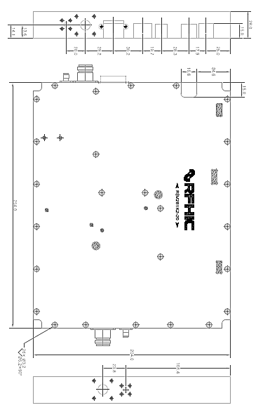

Revision History

Part Number | Release Date | Version | Description | Data Sheet Status
RIM281K2-20 | May, 2025 | 1.0 | Initial release of datasheet | Preliminary


Certification
This product is manufactured by a company that is certified for the AS9100D quality management system.
RFHIC Corporation reserves the right to make changes to any products herein or to discontinue any product at any time without notice. While product specifications have been thoroughly examined for reliability, RFHIC Corporation strongly recommends buyers to verify that the information they are using is accurate before ordering. RFHIC Corporation does not assume any liability for the suitability of its products for any particular purpose, and disclaims any and all liability, including without limitation consequential or incidental damages. RFHIC products are not intended for use in life support equipment or application where malfunction of the product can be expected to result in personal injury or death. Buyer uses or sells such products for any such unintended or unauthorized application, buyer shall indemnify, protect, and hold RFHIC Corporation and its directors, officers, stockholders, employees, representatives and distributors harmless against any and all claims arising out of such unauthorized use. All sales inquiries and support should be directed to the local authorized geographic distributor for RFHIC Corporation. For customers in the US, please contact the US sales team through our website at https://rfhic.com/rfhic-us/ . For all other inquiries, please contact our international sales team through our website portal at https://rfhic.com/contact/

