Product Features Applications

- 325 MHz (≥ +/-1 MHz)
- Output power: 2kW (CW) Peak 50V
- Built with GaN on SiC HEMT
- 70% System Efficiency
- High Reliability
- Power & Frequency Monitoring Available
- Building Block for High-Power Systems
- Accelerator Light Source
- Plasma Generation
- Industrial Heating and Drying
- Microwave CVD
- Microwave Sintering
- Microwave Chemistry
- Materials Processing
- Study of Biological Phenomena
- Semiconductor Equipment

Description
The RIM032K0-20 is a 2kW Solid-State Power Amplifier (SSPA) engineered with cutting-edge GaN on SiC HEMT technology, delivering exceptional efficiency and high breakdown voltage. This rugged amplifier is meticulously optimized to meet the stringent demands of linear accelerators (Linacs) and particle accelerator RF infrastructures..
Electrical Specifications @ VDS =50V, T=25°C, 50Ω System

PARAMETER | UNIT | MIN | TYP | MAX
Operating Frequency | MHz |  | 325
Operating Bandwidth | MHz | 324 |  | 326
CW Variable Output Power | W | 25 | - | 2000
Power Gain @Peak Power | dB |  | 72
RF Input power | dBm | -10 |  | -8
Efficiency (DC to RF) | % | - | - | 70
Operating Voltage | VDC | - | 50 | -
Max. Mismatch @ Max Output Power* | 6: 1 VSWR

Mechanical Specifications

PARAMETER | UNIT | VALUE
Dimensions (LⅹWⅹH) | mm | 360 x 200 x 66
Weight | kg | 6
RF Input Connector | - | SMA, Female
RF Output Connector |  | 7/16DIN, Female
DC & GND: DB-8W8 6-Pin Female | - | D-Sub 5W5
I/O Connector | - | SMAW200-14C
Cooling Type | - | Water Cooling Rate
Cooling Type | - | Cooling Water Inlet Temperature | 20°C~25°C ((typ.)
Cooling Type | - | Relative humidity below dew point (non-condensing)
Cooling Type | - | * De-ionized water shall be used to prevent system damage
Fluid Inlet/Outlet Size | Inch | 1/4 Tapered Pipe Thread

Note
Dimension and weight may be subject to change.
Mechanical drawing
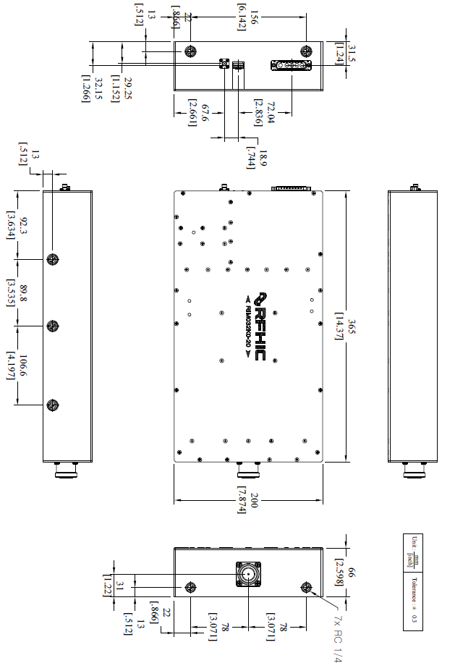

Interface Connector
12 Pin-Control (SMAW200-12C)
Pin No | Description | Pin No | Description
1 | GND | 2 | GND
3 | Voltage Monitoring | 4 | NC
5 | Forward power Monitoring | 6 | Current Monitoring
7 | RF Enable  (Low Enable) | 8 | Temperature Monitoring
9 | INPUT Monitoring | 10 | Gain Control (0~5V)
11 | Reverse power Monitoring | 12 | Phase Control (0~5V)

8 Pin-Power (3005W5SXX99A10X)
Pin No | Description | Pin No | Description
A1(131A10049X) | 50V | A2(131A10049X) | 50V
A3(131A10049X) | 50V | A4(131A10049X) | GND
A5(131A10049X) | GND

Revision History

Part Number | Release Date | Version | Description | Data Sheet Status
RIM032K0-20 | August, 2025 | 0.1 | Initial release of datasheet | Preliminary



Certification
This product is manufactured by a company that is certified for the AS9100D quality management system.
RFHIC Corporation reserves the right to make changes to any products herein or to discontinue any product at any time without notice. While product specifications have been thoroughly examined for reliability, RFHIC Corporation strongly recommends buyers to verify that the information they are using is accurate before ordering. RFHIC Corporation does not assume any liability for the suitability of its products for any particular purpose, and disclaims any and all liability, including without limitation consequential or incidental damages. RFHIC products are not intended for use in life support equipment or application where malfunction of the product can be expected to result in personal injury or death. Buyer uses or sells such products for any such unintended or unauthorized application, buyer shall indemnify, protect, and hold RFHIC Corporation and its directors, officers, stockholders, employees, representatives and distributors harmless against any and all claims arising out of such unauthorized use. All sales inquiries and support should be directed to the local authorized geographic distributor for RFHIC Corporation. For customers in the US, please contact the US sales team through our website at https://rfhic.com/rfhic-us/ . For all other inquiries, please contact our international sales team through our website portal at https://rfhic.com/contact/

